CUMANN na MBUNSCOL 2023
TABLE QUIZ FOR TEAMS OF FOUR
.
The annual Quiz is taking place in a number of Tyrone school venues today. The teams with the top three scores in the county will go forward to the Ulster Finals to be held in Cavan.

There are 10 rounds with 6 questions in each round.

All teams are to be asked the tie-breaker question. The answers to this question should be kept by the host school. This answer may have to be used to separate schools with the same scores in the various heats and can also be used, on the day, to decide the winners of heats in case of a tie.

Please email me your:
- top 3 schools & their scores
- top 3 schools’ tie-breaker answer.
Also, send a photo of these top 3 teams from your heat including medal winners.

*MAX Score: 60 [10 x 6]
– Do not include tie-breaker answer in score

Rounds 7 and 9 need to be photocopied or printed for each team.

Ádh mór!

Ulster Quiz Final
23rd March in Cavan

Round 1

- Who were the 2022 Ulster Men’s Senior Football Champions?
(Derry)

- The River Shannon flows through which Munster city?
(Limerick)

- Who is the Taoiseach or leader of the Government in Dublin?
(Leo Varadkar))

4. How many days are in the last six months of a year?
(184)

- Which Tyrone club team won the O’Neill Cup in 2022?
(Errigal Ciaran)

- What is the second largest city by population in Ireland.?
(Belfast)

Round 2

- Who is the current Manager the Derry Senior Football Team?
(Rory Gallagher)

- Who is the current GAA President?
(Larry McCarthy)

3. How many cities are there in the Province of Munster?
(3)

- Which team are the current Tyrone Intermediate Football Champions?
(Galbally – Pearse’s)

5. When will the next leap year occur?
(2024)

- Loch Garman is the Irish name for which County?
(Wexford)

Round 3

- What number do you get when you multiply the number counties in Leinster by the number of majors won by Rory McIlroy?
(48 12x4)

- True or False, there are 7 finger holes on a tin whistle?
(False, there 6 finger holes)

- According to The Chronicle of Ireland, in which year did St Patrick arrive in Ireland?
(431 AD)

- In which city did Molly Malone sell seafood?
(Dublin)

- Older than Stonehenge or the Egyptian pyramids, this burial monument was built around 3200 BC. What is its name?
(Newgrange)

- George William Russell, Seamus Heaney and Thomas Moore were famed for what?
(Poetry)

Round 4

- What currency is used in the Republic of Ireland?
(Euro)

- Which crop failed in 1845 creating the Great Famine?
(Potato)

- What is Conor McGregor's sport?
(Mixed Martial Arts MMA)

- Which traditional Irish musical instrument was adopted as a logo by both Guinness and Ryanair?
(The Harp.)
- The town of Ballycastle is in which Irish county?
(Antrim)
- Which company are the official sponsors of Tyrone Jerseys?
(McAleer and Rushe)

Round 5

- Who is said to have defended himself from a wolfhound with the help of only a hurl and a sliotar?
(Cuchulainn.)
- Which Tyrone Player has won the most football All Star awards?
(Sean Cavanagh)
- What does “O” in Irish surnames mean? eg O’Kane, O’Neill
(Grandson of)

- Which Irishman won the 2019 Open Golf Championship played in Portrush?
(Shane Lowry)

- Which player has won the most All Ireland Senior Hurling medals.
(Henry Shefflin)

- True or false, an Irish mile was longer than an English mile?
(True)

Round 6

- During the 9th century AD, which group of invaders plagued Irish shores?
(Vikings)

- What does the circle at the very centre of a Celtic cross represent?
(The Sun.)

- In Irish folklore what kind of ghost or fairy screams to warn of impending death and disaster?
(Banshee.)

- In which language was the Book of Kells written: Was it English, Latin or Irish?
(Latin.)

- Northern Bank £20 notes feature Harry Ferguson next to which type of vehicle?
(Tractor)

- Name the only remaining completely intact walled city in Ireland (it's one of the best examples of a walled city in Europe)?
(Derry)

Round 7
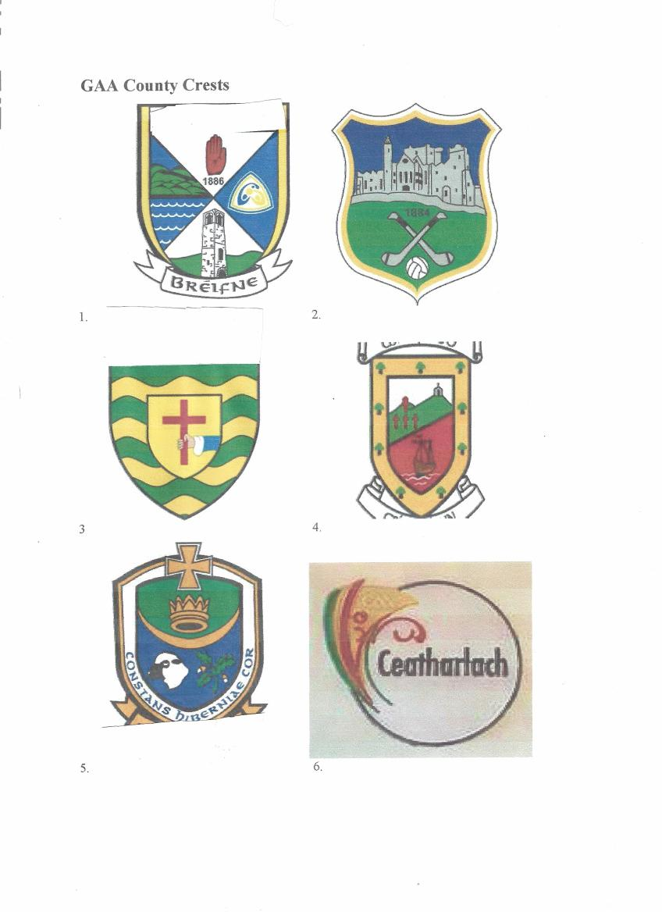

Answers Round 7
  - Cavan
  - Tipperary
  - Donegal
  - Mayo
  - Roscommon
  - Carlow

Round 8

- Hornpipes, reels and Polkas are traditional Irish what?
(Dances or Tunes)

- On what day of the week will St Patrick’s Day fall this year?
(Friday)

- Burr Point is the most Easterly place in Ireland, but which county is it in?
Is it Dublin, Down or Wexford?
(Down)

- What name was given to an artificial island dwelling place built on lakes by ancient Irish Settlers?
(Crannog)

- Which is the only Munster county not to have a coastline?
(Tipperary)

- What did Lir do to his wife Aoife after he discovered what he had done to his children?
(Turned her into a Demon of the air
(Accept banished her to the mist?))

Picture Round Round 9

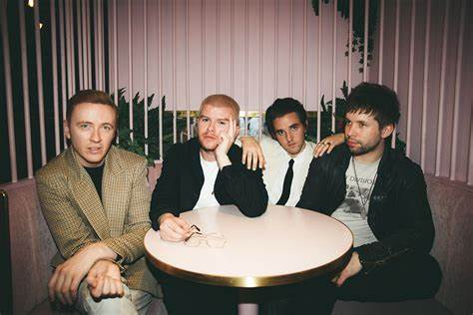 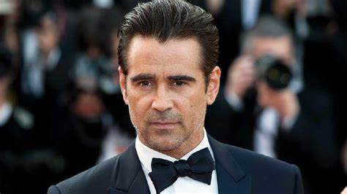1 2

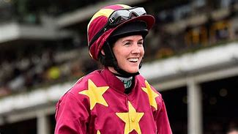
3 4

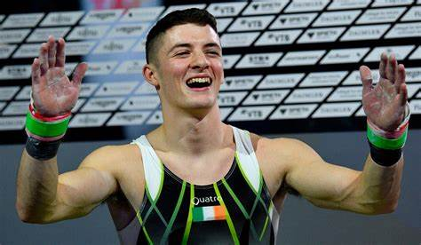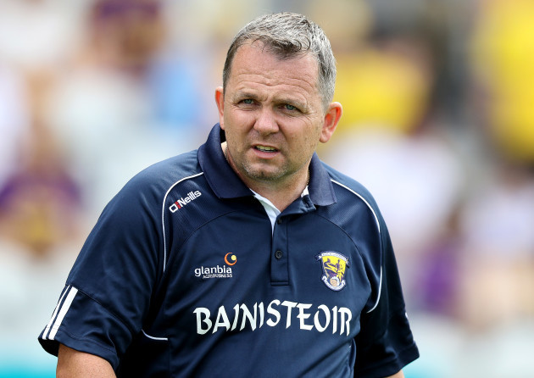
- 6.

Answers Round 9

1 Wild Youth (Irish Eurovision Entry 2023
2.Colin Farrell (Irish Actor nominated for an Academy Award)
3. Declan Hannon (Limerick Hurling Captain)
4. Rachel Blackmore (Horse Racing history maker)
5. Rhys McClenaghan (World Pommel Horse Champion 2022)
6. Davy Fitzgerald (Manager of Waterford Senior Hurling team)

Round 10

1.Which two Tyrone Clubs recently played in All Ireland Club Football Finals?
(Galbally and Stewartstown) Both answers needed.

- Who won the All Ireland Senior Camogie final in 2022?
(Kilkenny)

- For which English Premiership Club does Seamus Coleman play?
(Everton)

- Which quadrilateral has two pairs of equal sides, one pair of equal angles and no parallel lines?
(Kite)

- This River rises in County Kildare, flows north east through County Meath and reaches the Irish sea between Baltray County Louth and Mornington County Meath. Name this River
(River Boyne

- Which county has the largest population in Ulster?
(Antrim)

Tie Breaker Question

In total, how many All Ireland Senior Hurling Championships have been won by Munster counties?
(76)

